Task No & Title:  Unit 1 | Unit Descriptor This unit defines the competency required to operate a personal computer, including starting the PC, logging in, using and understanding desktop icons and their links to underlying programs, navigating a directory structure, saving work, printing, system checks and closing down the PC. This unit is a prerequisite to starting the course and should be completed as soon as possible.
Title: | Certificate II in Information Technology
Suitable for Classes: | Certificate II Information Technology
Area: | Technology & Enterprise  1
Teacher: | Mr Peter Faulks
Timeline | 1 Lesson
Date Due: | Today

Task Brief:

Files Required

Items highlighted in yellow are tasks for you to complete
Items in Blue are help tips

Certificate II in Information Technology

Unit | Number | Title | Type | Hours
01 | ICAU1128B | Operate personal computer | Pre | 20
02 | BSBCMN106A | Follow workplace safety procedures | Core | 10
03 | ICAD2012B | Design organisational documents using computing packages | Core | 40
04 | CAU2005B | Operate computer hardware | Core | 20
05 | ICAU2006B | Operate computing packages | Core | 60
06 | ICAU2013A | Integrate Commercial computing packages | Core | 25
07 | ICAU2231B | Use computer operating system | Core | 20
08 | ICAW2001B | Work effectively in an IT environment | Core | 25
09 | ICAW2002B | Communicate in the workplace | Elective | 20
10 | ICAS2014B | Connect Hardware Peripherals | Elective | 25
11 | ICAU2007B | Maintenance of equipment and consumables | Elective | 15
12 | ICPMM263B | Access and use the internet | Elective | 20
13 | ICAW2011B | Work individually or as a team member | Elective | 20
14 | ICPMM321B | Capture a digital image | Elective | 30
 |  |  | TOTAL


This document is your first step to the Certificate II in Information Technology

This document covers

Unit 1 Operate personal computer Switching on a computer (Credit 1 hour)

Certificate II in Information Technology

Checklist of electronic, work and portfolio filing systems
Design organisational documents using computing packages
Set Up Files

Name: | Competent | Yes | Not Yet

Using Unit 01 open the file 01_01 Operator Start and follow the instructions

NOTE: The files you use should (usually) follow in sequence so you open 01 which stands for Unit 01 and File 01 which is the sequence of files to open (01_02 is next).

You will create a folder for each unit titles Unit 01 the another Unit 02 etc. and this is where you will save all your work for marking.

Unit 01-01 This will show you how to start up your computer Windows or Mac and how to create and save folders to your workspace or USB Thumb Drive.
I STRONGLY suggest that you keep a back up copy of ALL your work on a USB portable drive.

Once you have completed UNIT 01_01 and have saved your work, return to this document and complete this document (Setting up your Portfolio Files)

Open 01_01 Operator Start now…

This document is saved as 01_01 Set Up Portfolio Files – SAVE THIS DOCUMENT to Folder UNIT 01


If you do not understand or need help please ask

Next lesson we will create cover pages for each unit.

Before we set up our Portfolio a little test (worth 1 hour credit)

Task: Desktop configurations

Name the parts of the desktop in the picture below and the function of each.
Draw arrows and text boxes to complete a help page of the desktop. If on a Mac use the Mac window below. (Delete one of these images first)



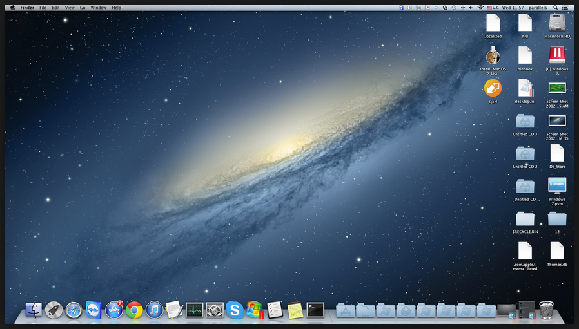

2. Explain what a computer system is?
Answer:

3. State the main parts of a computer and various hardware components
Answer:

4. State the main types of computers
Answer:

Section 1 Practical

Task Requirements
The task requires that you set up your electronic filing space, work folder and evidence portfolio in accordance with the following guidelines

Due Date
This task is due today
It is your responsibility to ensure that this task is submitted on time. If you are unable to submit this task on the specified date, it is your responsibility to see me to negotiate any extensions or any extra assistance that may be require.

Task Feedback
Your electronic filing system must contain the following (this must be evidenced through a print screen print out):

You must create a MASTER folder in your work space titled C2IT

Within that folder you are to create the following sub folders:
Use Unit 01, Unit 02 etc. as your folder titles.
Unit 01 | Operate personal computer
Unit 02 | Follow workplace safety procedures
Unit 03 | Design organisational documents using computing packages
Unit 04 | Operate computer hardware
Unit 05 | Operate computing packages
Unit 06 | Integrate Commercial computing packages
Unit 07 | Use computer operating system
Unit 08 | Work effectively in an IT environment
Unit 09 | Communicate in the workplace
Unit 10 | Connect Hardware Peripherals
Unit 11 | Maintenance of equipment and consumables
Unit 12 | Access and use the internet
Unit 13 | Work individually or as a team member
Unit 14 | Capture a digital image
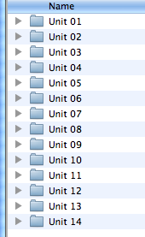


Cert2IT

Binder

- Your evidence portfolio (A4 Binder with dividers provided to you) must contain the following:
- Spine Label
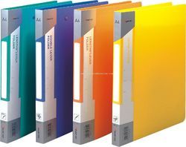
- 5 file dividers with the following labels:
- Course Documents
- Term 1
- Term 2
- Term 3
- Student Assessment Record

- Your work folder (provided by you) must contain the following:
- A two ring binder.
- A cover page with your name.
- 18 File dividers with the following sections:

Unit 01 | Operate personal computer
Unit 02 | Follow workplace safety procedures
Unit 03 | Design organisational documents using computing packages
Unit 04 | Operate computer hardware
Unit 05 | Operate computing packages
Unit 06 | Integrate Commercial computing packages
Unit 07 | Use computer operating system
Unit 08 | Work effectively in an IT environment
Unit 09 | Communicate in the workplace
Unit 10 | Connect Hardware Peripherals
Unit 11 | Maintenance of equipment and consumables
Unit 12 | Access and use the internet
Unit 13 | Work individually or as a team member
Unit 14 | Capture a digital image

Insert screen shot here:
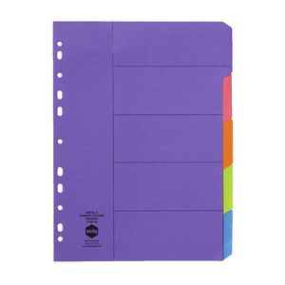

ASSESSOR FEEDBACK FORM
Student Name:
Assessment Date/Due |  | Assessor’s Name: | Peter J Faulks
Training Package: | ICA05
Qualification: | ICA20105 Certificate II in Information Technology

FEEDBACK FOR FUTURE ACTION
Overall performance, gaps and feedback:

Assessment Record | Satisfactorily Completed
Task 1: Practical Activities | Yes | No
Task 2: Written Questions | Yes | No
Task 3: Observation | Yes | No

Is a reassessment required? Circle  Date of Reassessment if applicable: _____________________ | Satisfactorily Completed
   | Yes | No
Task 1: Practical Activities | Yes | No
Task 2: Written Questions | Yes | No
Task 3: Observation | Yes | No

Assessment of Competency completed: _____/_____/_____

Outcome: (Tick)
Competent |  | Not yet competent

Candidate Signature: | Date:
Assessor Signature: | Date:

Teacher Comment & Signature

Student Comment and Signature

